PEEL WATER STORY
TEACHER HANDBOOK

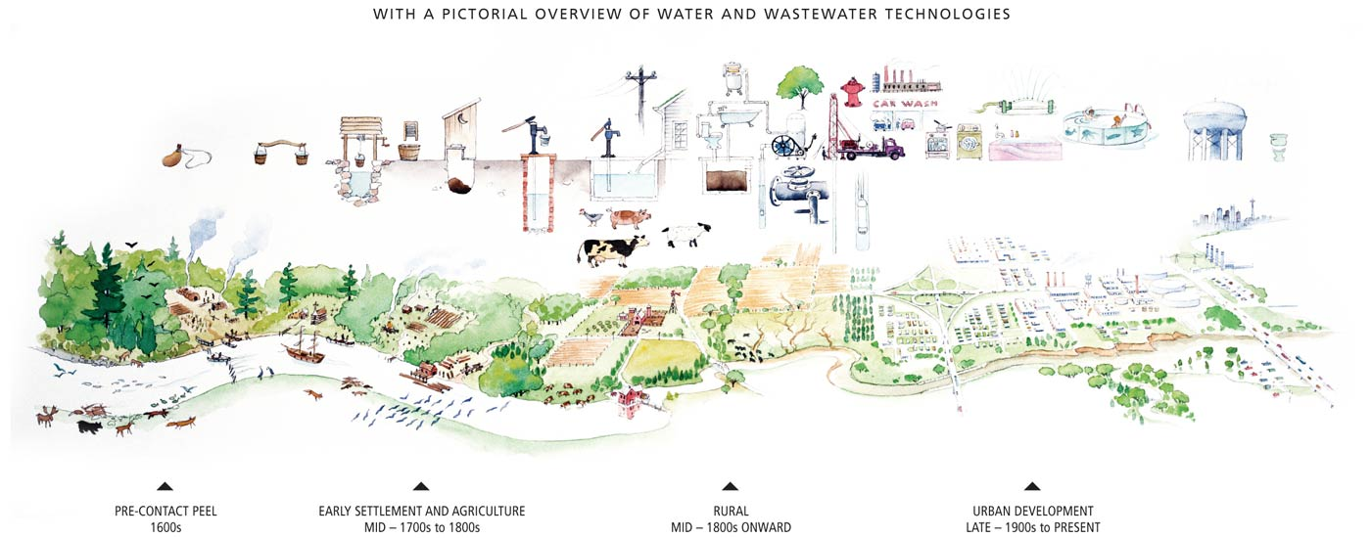

What we do on the land is mirrored in the water.
Table of Contents
Introduction 1
Lay of the Land: 1
Module Overview 1
Handout Answer sheets 2
GIS Activity: Your Watershed Address 2
GIS Activity: Go with the Flow 4
GIS Activity: Your Watershed Address 6
Curriculum Connections 8
Rain to Drain 1
Module Overview 1
Handout Answer sheets 2
GIS Activity: Growth and Water Supply 2
GIS Activity: What Lies Beneath 4
GIS Activity: From Source to Sink 5
GIS Activity: Human Water Cycle 6
GIS Activity: Growth and Water Supply 7
GIS Activity: What Lies Beneath 9
GIS Activity: From Source to Sink 10
Curriculum Connections 12
Taking the Plunge 1
Module Overview 1
Handout Answer sheets 2
Graphing Chloride in the Credit 2
Mississauga News: Diesel Spill Article 5
Graphing Chloride in the Credit 6
Curriculum Connections 10

Introduction
The Peel Water Story is a series of online learning modules for educators and students in grades 5-12 to learn about local watersheds, water sources, and water quality. The modules use the ArcGIS Online Story Map application, include an introductory element of Geographic Information Systems (GIS), and can be adapted for multiple subject areas. Each module is curriculum-linked and designed to be completed in 40 minutes or less. The modules can be used to deliver an individual lesson or kick-start further exploration and learning.

The Peel Water Story contains 3 modules that were tested and improved upon through feedback from Peel Region District School Board and Dufferin-Peel Catholic District School Board teachers. The modules can be completed in any order.

Module | After completing this module, students will be able to:
Lay of the Land | - Define a watershed  - Use an online map to identify which watershed they live in as well as nearby waterbodies  - Define stormwater and runoff  - Be able to explain the various parts of a stormwater system and why a stormwater system is required
Rain to Drain | - Define surface water and groundwater  - Identify the source and route of their tap water  - Identify the destination and route of their wastewater  - View changes in land use over time
Taking the Plunge | - Define point and non-point source pollution  - Understand how pollutants such as salt enter and impact our watersheds  - Identify the steps taken following a spill

Why GIS?
- Provides real data for students to explore and connect with their community
- Connects students to infrastructure elements that would otherwise be hidden underground or not accessible to the public
- Helps students understand content in many disciplines including geography, history, math, environmental studies, biology, chemistry and enables teachers to find multiple entry points into their curriculum
- Helps visualize data and provide real world applications

Lay of the Land:

Module Overview
Length of lesson: 40 minutes
Preparation: Access to computer lab or class set of laptops/tablets
Key Themes: Review of water cycle, watersheds, stormwater, urbanization and watershed health
Learning Goals:
At the end of this module students will be able to:
- Define a watershed
- Use an online map to identify which watershed they live in, and what waterbodies are located within their watershed
- Define stormwater and runoff
- Explain the various components of a stormwater system and their importance
Additional Opportunities for Discussion:
What are the important natural and historical features in your watershed? How are you connected to the existing ecosystems?

Think about human interventions and how they can impact the watershed. Discuss which have harmed the natural ecosystems and what human interventions are trying to tackle these issues.

How do household and industry activities in your community impact the health of your watershed?

Handout Answer sheets

GIS Activity: Your Watershed Address

NOTE: Answers to this handout will vary based on the school selected. This answer sheet uses Thomas Street Middle School as an example.
Familiarize yourself with the watershed map. Identify the various icons you will need on the map, including the search bar, layers icon and zoom functions.

- Your Watershed Address
Use the following steps to identify the watershed you live in:
Select the search icon and enter your school address. Make sure the suggested address that appears is in the same city and country before selecting it.
Zoom out until the name of your watershed appears. What watershed is your school located in?

Thomas Street Middle School-2640 Thomas St, Mississauga, Ontario, L5M 5G8
Watershed-Credit River

- Nearby Water
Use the following steps to follow the water flowing through your watershed:
Select the layers icon and turn on the rivers, creeks and streams layer.

- Begin at your school and zoom out until you identify the nearest river, stream or creek. What is the name of the nearest river, stream or creek?

The closest creek is Mullet Creek

- Follow this body of water. Does it connect to another stream, creek, or river? If yes, what is the name of this second river, creek or stream?

Yes, it connects to the Credit River.

- Keep following the water. What larger body of water does the final river, creek or stream empty into?

Lake Ontario

- After watching the videos and using the maps, reflect on water on your school ground. Think about areas where water travels, creates puddles, is absorbed, or goes down a drain. Describe how rainwater might move through your school ground.

Water around my school grounds would pool and flow into catch basins which lead into nearby creeks and rivers. Not much of it would be absorbed on the school grounds because there is mostly pavement and few greenspaces.

- How do you think this movement or storage of water on your school ground can impact the larger watershed?
Since water would runoff the school’s grounds into nearby waterways and not be absorbed greenspaces it would cause an increase in water levels in the larger watershed.

GIS Activity: Go with the Flow
Familiarize yourself with this map. Identify the various icons you will need on the map, including the search bar, layers icon and zoom functions.
Follow these steps to compare storm water catch basins on school grounds.
- Select the search icon and enter 296 Conestoga Dr, Brampton, Ontario. This address will take you to Heart Lake Secondary School.
Select the layers icon and prepare your map by:
- Turning off (take off the check mark) for the City of Brampton Manholes layer
- Turning on (keep the checkmark) for the City of Brampton Catch Basins layer
Zoom in until you can see the school property and surrounding streets.
How many catch basins are located on the Heart Lake Secondary School property?
Between 13-15
- Using the same steps, count the number of catch basins at 10815 Dixie Road, Brampton, Ontario (St. Marguerite d’Youville Secondary School)
How many catch basins are located on the St. Marguerite d’Youville Secondary School property?
Between 30-35
- Describe the surfaces that immediately surrounds each school below.

The surface that surrounds Heart Lake Secondary School includes many greenspaces including parks and Etobicoke Creek. The surface area that surrounds St. Marguerite d’Youville Secondary School property is a lot more developed consisting of only houses and roads with no parks or greenspaces nearby.

- Based on your understanding of storm water and runoff, what area around each school would contribute to more runoff? What area would reduce runoff?
Roads and developed land are non permeable surfaces. This means that melted snow and rain would not be able to soak into these surfaces and would pool in areas. Areas with more grass, plants and greenspaces will soak up much more rainwater and snow melt. The area that surrounds St Marguerite d’Youville Secondary School would contribute to more runoff because if has less greenspaces and more roads and houses. The land surrounding Heart Lake Secondary Schools is less developed and contains mostly greenspaces, this will reduce runoff as the water can be absorbed into the plants and soil.

- If your school is in Brampton, search for it and look at the school grounds. How does your school compare to the other schools? (Note: at this time, storm water data is only available for the City of Brampton).
Answers will vary depending on the school chosen.

GIS Activity: Your Watershed Address

Name:
Familiarize yourself with the watershed map. Identify the various icons you will need on the map, including the search bar, layers icon and zoom functions.
- Your Watershed Address
Use the following steps to identify the watershed you live in:
Select the search icon and enter your school address. Make sure the suggested address that appears is in the same city and country before selecting it.
Zoom out until the name of your watershed appears. What watershed is your school located in?

- Nearby Water
Use the following steps to follow the water flowing through your watershed:
Select the layers icon and turn on the rivers, creeks and streams layer.
Begin at your school and zoom out until you identify the nearest river, stream or creek. What is the name of the nearest river, stream or creek?

Follow this body of water. Does it connect to another stream, creek, or river?

If yes, what is the name of this second river, creek or stream?

Keep following the water. What larger body of water does the final river, creek or stream empty into?

- After watching the videos and using the maps, reflect on water on your school ground. Think about areas where water travels, creates puddles, is absorbed, or goes down a drain. Describe how rain water might move through your school ground.

- How do you think this movement or storage of water on your school ground can impact the larger watershed?

GIS Activity: Go with the Flow

Name:
Familiarize yourself with this map. Identify the various icons you will need on the map, including the search bar, layers icon and zoom functions.
Follow these steps to compare storm water catch basins on school grounds.
Note: Storm water data is available for the City of Brampton ONLY.
- Select the search icon and enter 296 Conestoga Dr, Brampton, Ontario. This address will take you to Heart Lake Secondary School.
Select the layers icon and prepare your map by:
- Turning off (take off the check mark) for the City of Brampton Manholes layer
- Turning on (keep the checkmark) for the City of Brampton Catch Basins layer
Zoom in until you can see the school property and surrounding streets.
How many catch basins are located on the Heart Lake Secondary School property?

- Using the same steps, count the number of catch basins at 10815 Dixie Road, Brampton, Ontario (St. Marguerite d’Youville Secondary School)
How many catch basins are located on the St. Marguerite d’Youville Secondary School property?

- Describe the surfaces that immediately surrounds each school below.

- Based on your understanding of storm water and runoff what area around each school would contribute to more runoff? What area would reduce runoff?

- If your school is in Brampton, search for it and look at the school ground. How does your school compare to the other schools?

Curriculum Connections
Grade | Subject & Unit | Specific Expectations
6 | Science and Technology: Understanding life systems | - Assess human impacts on biodiversity, and identify ways of preserving biodiversity
7 | Science and Technology: Understanding life systems | - Assess the impacts of human activities and technologies on the environment, and evaluate ways of controlling these impacts
 | Science and Technology: Understanding matter and energy | - Evaluate the social and environmental impacts of the use and disposal of pure substances and mixtures
8 | Science and Technology: Understanding earth and space systems | - Assess the impact of human activities and technologies on the sustainability of water resources  - Investigate factors that affect local water quality  - Demonstrate an understanding of the characteristics of the Earth’s water systems and the influence of water systems on a specific region
9 | Science | - Assess the impact of human activities on the sustainability of terrestrial and/or aquatic ecosystems, and evaluate the effectiveness of courses of action intended to remedy or mitigate negative impacts  - Investigate factors related to human activity that affect terrestrial and aquatic ecosystems, and explain how they affect the sustainability of these ecosystems
 | Geography: The Physical Environment and Human Activities | - Analyse various interactions between physical processes, phenomena, and events and human activities in Canada
 | Geography: The Characteristics of Canada’s Natural Environment | - Describe various characteristics of the natural environment and the spatial distribution of physical features in Canada, and explain the role of physical processes, phenomena, and events in shaping them
10 | Science | - Investigate various natural and human factors that influence Earth’s climate and climate change
11 | Geography: Patterns of Natural and Human Systems | - Describe patterns in natural features and population distribution in the selected region, and analyse the relationship between them
 | Environmental Science | - Investigate air, soil, and water quality in natural and disturbed environments, using appropriate technology

Rain to Drain

Module Overview
Length of lesson: 40 minutes
Preparation: Access to computer lab or class set of laptops/tablets
Key Themes: Water sources, groundwater, surface water, urbanization and water supply
Learning Goals:
At the end of this module students will be able to:
- Define surface water and groundwater
- Use an online map to identify the source and route of their tap water
- Use an online map to identify the destination and route of their wastewater
- Use an online map to view changes in land-use over time and be able to explain how different land use practices can influence water supply
Additional Discussion Opportunities:
Discuss the use of tap water and bottled water and how they are different. Have students research the sources of bottled water.
Discuss growth and change throughout the Region over time and how patterns of land use have changed.
Have students research the history of the Etobicoke Creek, the settlement of downtown Brampton, issues with flooding, and the large construction project to divert the creek. Discuss how the diversion impacted humans, animals and natural features surrounding the creek.

Handout Answer sheets

GIS Activity: Growth and Water Supply
NOTE: Answers to this handout will vary. This answer sheet uses Thomas Street Middle School has been used as an example.
Familiarize yourself with the watershed map. Identify the various icons you will need on the map, including the search bar, time slider icon, legend icon and zoom functions.
Use this map to explore how land use has changed over time in a community within the Region of Peel as well as in your own community.
Follow these steps to show an example of development and land use change in the Region of Peel:
- Select the search icon and enter Bolton, Caledon, Ontario.
Select the legend icon and review the different land use categories.
What is the most common land use in the community of Bolton and the immediate surrounding area?
Rural
- Select the time slider icon to begin to see how the area has developed over time. You can pause the time slider as needed.
Has the land use category changed in and around Bolton? What kind of development do you notice?
There was little change in Bolton land use up until 2003-2013 when it residential land use expanded dramatically. There was only a small area of residential land with the rest of the land type not labelled until 2003.
- How might these developments impact the water source? Do you think the water still comes from the same source today as it did in 1950? Why or why not?
The more developed the land the more it will impact the water source. As the area around Bolton and throughout Peel Region became more developed, we saw more residential, employment and institutional uses of land. These land uses would have increased the amount of pollution, run off and other factors that impact our water sources today and increased demands for water use. Areas like Brampton and the community of Bolton previously relied heavily on groundwater for their source of water but as the land became more developed and the population grew, they would have switched to Lake Ontario as their water source.

- Try using the map to view development and land use changes in your neighbourhood.
Select the search icon and enter your school address. Make sure the suggested address that appears is in the same city and country before selecting it.
Begin at your school and zoom out until you have a view of the surrounding neighbourhood.
Thomas Street Middle School
Select the legend icon and review the different land use categories.
What is the most common land use immediately surrounding your school?
Residential
- Select the time slider icon to begin to see how the area has developed over time. You can pause the time slider as needed.
Has the land use category changed in and around your neighbourhood? What kind of development do you notice?
Prior to 1973 there was very little developed land around the school. The land closer to the lake was residential and throughout the years moved up and further from the lake. Between 1983-1993 the area around my school was completely residential.

GIS Activity: What Lies Beneath
Using the wastewater infrastructure map, follow these steps to trace the route that the wastewater (sewage water) takes to get from your school to the Wastewater Treatment Plant.

Familiarize yourself with the map. Identify the various icons you will need on the map, including the search bar, layers icon and zoom functions.
- Zoom in so that your school and Lake Ontario are both displayed on the screen.
Using the layers icon, make sure that the following layers are turned on:
- Wastewater Treatment Plant- Active
- Wastewater Main Diameter Greater than 600mm
Turn off all other layers to make it easy to view the relevant layers.
Can you spot the two Wastewater Treatment Plants located on the shores of Lake Ontario? What are the names of the two Wastewater Treatment Plants?
Clarkson Wastewater Treatment Plant
Lakeview Wastewater Treatment Plant

- Using the layers icon turn on the wastewater main layer.

The Wastewater Main Trunks are the largest wastewater pipes that carry wastewater from schools, homes and business to the Wastewater Treatment Plant. To trace the flow of wastewater from your school to the Wastewater Treatment Plant turn on the wastewater main layer. As you zoom in on the map you will notice that the smaller wastewater mains become visible.
What is the name of the Wastewater Treatment Plant that is closest to your school?
Clarkson Wastewater Treatment Plant
What sizes are the wastewater main trunks that leave the Wastewater Treatment Plant? (the size is provided in millimeters)
3000mm
- Zoom in to your school property. What is the size of the wastewater main outside your school? (the size is provided in millimeters)
600mm

GIS Activity: From Source to Sink
Using the water infrastructure map, follow these steps to learn where your water comes from and the journey it takes to arrive at your tap. Don’t forget that Peel's water treatment systems can be divided into two categories: two surface water treatment facilities and multiple groundwater treatment sites.

Familiarize yourself with the map. Identify the various icons you will need on the map, including the search bar, layers icon and zoom functions.
- Zoom in so that your school and Lake Ontario are both displayed on the screen.
Using the layers icon, make sure that the following layers are turned on:
- Water Treatment Plant- Active
- Water Main Diameter Greater than 700mm
Turn off all other layers to make it easy to view the relevant layers.
Can you spot the two Water Treatment Plants located on the shores of Lake Ontario? What are the names of the two Water Treatment Plants?

Arthur P Kennedy Water Treatment Plant
Lorne Park Water Treatment Plant

- Using the layers icon turn on the water main layer.

The Water Main Trunks are the largest water mains that carry water from the water treatment plant to smaller water mains leading to homes, schools and businesses. Trace the water flow from the Water Treatment Plant to your school area. As you zoom in on the map you will notice that the smaller water mains become visible.

What is the name of the Water Treatment Plant that is closest to your school?

Lorne Park Water Treatment Plant

What size is the water main trunk that leaves the Water Treatment Plant? (the size is provided in millimeters)

2100 mm

- Zoom in to your school property. What is the size of the water main outside your school? (the size is provided in millimeters)
600 mm

GIS Activity: Human Water Cycle
In this final map you can view and compare both water and wastewater infrastructure in Peel.
Familiarize yourself with the map. Identify the various icons you will need on the map, including the search bar, layers icon and zoom functions.
- Using the layers icon, turn on the following layers:
- Water main diameter greater than 700
- Wastewater main diameter greater than 600
- Turn off all other layers to make it easy to view the relevant layers.

- Why do you think the wastewater trunks follow a curvy route to reach the Wastewater Treatment Plant, rather than running in straight lines like the water main trunks?

Wastewater trunks follow the natural slope of the land and rely on gravity to reach the wastewater treatment plants while the water main trunks must move slightly uphill to homes and institutions and must be pumped. It makes most sense for the water to be pumped in one straight line rather than curved.

What layer on the map can you turn on to confirm your theory?

Rivers, creeks and streams as they follow the natural slope of the land and match the route of the wastewater trunks.

GIS Activity: Growth and Water Supply

Name:
Familiarize yourself with the watershed map. Identify the various icons you will need on the map, including the search bar, time slider icon, legend icon and zoom functions.
Use this map to explore how land use has changed over time in a community within the Region of Peel as well as in your own community.
Follow these steps to show an example of development and land use change in the Region of Peel:

- Select the search icon and enter Bolton, Caledon, Ontario.
Select the legend icon and review the different land use categories.

What is the most common land use in the community of Bolton and the immediate surrounding area?

- Select the time slider icon to begin to see how the area has developed over time. You can pause the time slider as needed.

Has the land use category changed in and around Bolton? What kind of development do you notice?

- How might these developments impact the water source? Do you think the water still comes from the same source today as it did in 1950? Why or why not?

- Try using the map to view development and land use changes in your neighbourhood.

Select the search icon and enter your school address. Make sure the suggested address that appears is in the same city and country before selecting it.

Begin at your school and zoom out until you have a view of the surrounding neighbourhood.

Select the legend icon and review the different land use categories.

What is the most common land use immediately surrounding your school?

- Select the time slider icon to begin to see how the area has developed over time. You can pause the time slider as needed.

Has the land use category changed in and around your neighbourhood? What kind of development do you notice?

GIS Activity: What Lies Beneath

Name:
Using the water infrastructure map, follow these steps to learn where your water comes from and the journey it takes to arrive at your tap. Don’t forget that Peel's water treatment systems can be divided into two categories: two surface water treatment facilities and multiple groundwater treatment sites.

Familiarize yourself with the map. Identify the various icons you will need on the map, including the search bar, layers icon and zoom functions.
- Zoom in so that your school and Lake Ontario are both displayed on the screen.
Using the layers icon, make sure that the following layers are turned on:
- Water Treatment Plant- Active
- Water Main Diameter Greater than 700mm
Turn off all other layers to make it easy to view the relevant layers.
Can you spot the two Water Treatment Plants located on the shores of Lake Ontario? What are the names of the two Water Treatment Plants?

- Using the layers icon turn on the water main layer.

The Water Main Trunks are the largest water mains that carry water from the water treatment plant to smaller water mains leading to homes, schools and businesses. Trace the water flow from the Water Treatment Plant to your school area. As you zoom in on the map you will notice that the smaller water mains become visible.

What is the name of the Water Treatment Plant that is closest to your school?

What size is the water main trunk that leaves the Water Treatment Plant? (the size is provided in millimeters)

- Zoom in to your school property. What is the size of the water main outside your school? (the size is provided in millimeters)

GIS Activity: From Source to Sink

Name:
Using the wastewater infrastructure map, follow these steps to trace the route that the wastewater (sewage water) takes to get from your school to the Wastewater Treatment Plant.

Familiarize yourself with the map. Identify the various icons you will need on the map, including the search bar, layers icon and zoom functions.
- Zoom in so that your school and Lake Ontario are both displayed on the screen.
Using the layers icon, make sure that the following layers are turned on:
- Wastewater Treatment Plant- Active
- Wastewater Main Diameter Greater than 600mm
Turn off all other layers to make it easy to view the relevant layers.
Can you spot the two Wastewater Treatment Plants located on the shores of Lake Ontario? What are the names of the two Wastewater Treatment Plants?
- Using the layers icon turn on the wastewater main layer.

The Wastewater Main Trunks are the largest wastewater pipes that carry wastewater from schools, homes and business to the Wastewater Treatment Plant. To trace the flow of wastewater from your school to the Wastewater Treatment Plant turn on the wastewater main layer. As you zoom in on the map you will notice that the smaller wastewater mains become visible.
What is the name of the Wastewater Treatment Plant that is closest to your school?

What sizes are the wastewater main trunks that leave the Wastewater Treatment Plant? (the size is provided in millimeters)

- Zoom in to your school property. What is the size of the wastewater main outside your school? (the size is provided in millimeters)
GIS Activity: Human Water Cycle

Name:
In this final map you can view and compare both water and wastewater infrastructure in Peel.
Familiarize yourself with the map. Identify the various icons you will need on the map, including the search bar, layers icon and zoom functions.
- Using the layers icon, turn on the following layers:
- Water main diameter greater than 700
- Wastewater main diameter greater than 600
- Turn off all other layers to make it easy to view the relevant layers.

- Why do you think the wastewater trunks follow a curvy route to reach the Wastewater Treatment Plant, rather than running in straight lines like the water main trunks?

What layer on the map can you turn on to confirm your theory?

Curriculum Connections
Grade | Subject & Unit | Specific Expectations
5 | Science and Technology: Understanding matter and energy | - evaluate the social and environmental impacts of processes used to make everyday products
8 | Science and Technology: Understanding earth and space systems | - assess the impact of human activities and technologies on the sustainability of water resources  - demonstrate an understanding of the characteristics of the earth’s water systems and the influence of water systems on a specific region
9 | Geography: The Physical Environment and Human Activities | - analyse various interactions between physical processes, phenomena, and events and human activities in Canada
 | Geography: Demographic Patterns and Trends | - analyse patterns of population settlement and various demographic characteristics of the Canadian population
10 | Science | - investigate various natural and human factors that influence Earth’s climate and climate change
11 | Chemistry | - Analyse the origins and effects of water pollution, and a variety of economic, social, and environmental issues related to drinking water
 | Geography: Patterns of Natural and Human Systems | - describe patterns in natural features and population distribution in the selected region, and analyse the relationship between them
12 | Biology | - Analyse the relationships between population growth, personal consumption, technological development, and our ecological footprint, and assess the effectiveness of some Canadian initiatives intended to assist expanding populations

Taking the Plunge

Module Overview
Length of lesson: 40 minutes
Preparation: Access to computer lab or set of laptops/tablets
Key Themes: Categories of water pollution (point source and non-point source), salt and chloride levels in our watersheds and spill cleanup protocols
Learning Goals:
At the end of this module students will be able to:
- Define point source and non-point source pollution
- Understand the negative impacts of salt our watersheds
- Use an online map to identify areas in their watersheds with high levels of chloride
- Understand how spills are treated and cleaned up in our waterways

Additional Discussion Opportunities:
What are some other examples of point source and non-point source pollution in our Region?
Can you think of a time where pollution (point source or non-point source) has affected your daily life?
Think about why salt might affect species of native plants and animals in our watershed, even though it is a natural substance and is found in many different waterways across the world. Discuss which types of animals or species would be more affected by high salt concentrations than others.
What are some ways we could prevent or decrease the number of point source spills occurring in our Region? What about our country?

Handout Answer sheets

Graphing Chloride in the Credit
Familiarize yourself with the map. Identify the icons you will need on the map, including the search bar, layers icon and zoom functions.
1. Chloride Levels
Use the following steps to fill in the chart below:
Zoom out until you can see the entire Region of Peel on your screen.
- Select the layers icon and make sure that the Chloride Monthly Average layer is on.

Select the purple dots that represent the locations listed on the table below. Use the data to complete the table below.

- Select the layers icon and make sure that the land use layer is turned on.
Identify the land use by selecting the land use immediately surrounding each location on the map (this may include more than one type of land use). Fill in the land use type(s) for each location in the table below.

Location | January Monthly Average  Chloride (mg/L) | April Monthly Average  Chloride (mg/L) | August Monthly Average  Chloride (mg/L) | November Monthly Average Chloride (mg/L) | Land Use Type
Credit River at Highway 10 | 550 | 231 | 272 | 431 | Rural
Credit River at Belfountain Conservation Area | 51 | 41 | 48 | 88 | Conservation Area
Fletchers Creek | 1,470 | 541 | 264 | 368 | Estate
Cooksville Creek at Lakeshore | 3,318 | 1,188 | 493 | 2,181 | Employment

- Graphing Chlorides
Use the information from the table to plot the data on the graph paper provided below. Use a pencil crayon and ruler to connect the dots representing each location. For example, use red to connect the dots you plotted for the Credit River at Highway 10 location and a green to connect the dots you plotted for the Fletchers Creek location.

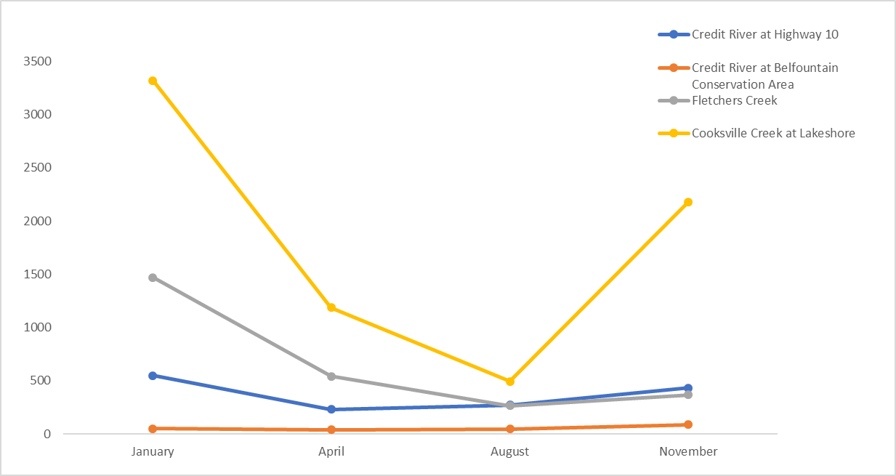

Now use the table and graph you’ve created to answer the questions below about the 2019 the Credit River chloride levels.

- At which location are chloride levels the highest? In which month does this occur? Why do you think chloride levels are the highest in this month?

Chloride levels are the highest at Cooksville Creek at Lakeshore. They are the highest in January. The chloride levels are the highest in this month because it is winter and more road salt is being used on icy roads and sidewalks.
- What kind of land use is associated with the highest chloride levels? What kind of land use is associated with the lowest chloride levels? What patterns or changes do you notice about chloride levels in urban areas versus chloride levels in rural areas?

The land use type that is associated with the highest chloride levels are employment areas. The and use type associated with the lowest chloride levels are conservation areas. In more rural areas the chloride levels stay relatively constant in all four months, in urban areas the levels increase dramatically during winter months (November and January).

- According to the Canadian Water Quality Guidelines for the Protection of Aquatic Life, the long-term exposure limit for certain freshwater species is 120 mg/L of chloride. This number is used to identify areas where chloride levels are high enough to negatively impact aquatic plants and fish. Use a pencil crayon and ruler draw a line to show 120 mg/L on your graph above. Do any of the locations exceed the long-term exposure limit? Are any of the locations below the long-term exposure limit?

The only location below the long-term exposure limit is Credit River at Belfountain Conservation Area. The Credit river at Highway 10, Cooksville Creek at Lakeshore and Fletchers Creek are all above the long-term exposure limit of 120 mg/L. This means that all locations (other than Credit River at Belfountain Conservation Area) have chloride levels that are far too high for certain aquatic plant and fish species and can cause negative impacts to the species found in these locations.

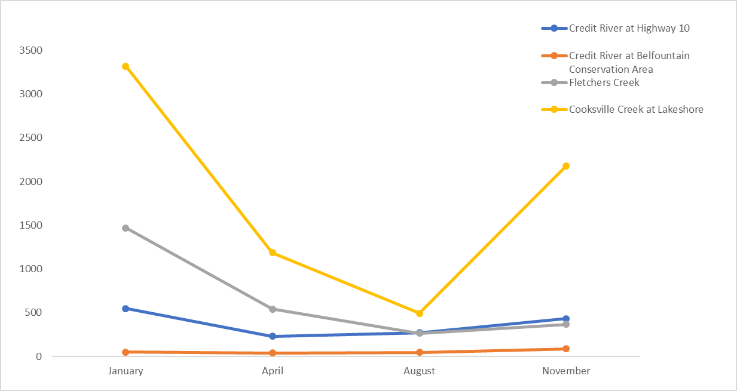

Mississauga News: Diesel Spill Article
- Read the section called Mississauga News: Diesel Spill Article and answer the questions below.
- What was spilled?
Diesel

- What was the source of the spill?
A ruptured saddle tank from the tow truck caused the diesel to spill into the basin.

- Is this an example of point source or non-point source pollution?
Point source pollution because the source of the spill was identified to one location.

- How was the spill treated and cleaned up?
A boom was placed on the spill to contain it and prevent it from travelling downstream. The boom was left overnight to help soak up the diesel.

- Use the internet to research Spill Coordinator careers and describe the academic and professional experience required for this job. Try searching for oil spill coordinator, environmental response coordinator, and environmental technician to expand the search.

For this position a Bachelor of Science degree is typically required in Mechanical, Environmental or Maritime disciplines. Excellent leadership and problem-solving skills are required as they must be able to direct instructions clearly and problem solve on demand as spills can change rapidly. Other requirements include First Aid training, heavy equipment operations and experience in working with chemical compounds.

Graphing Chloride in the Credit
Name:
Familiarize yourself with the map. Identify the icons you will need on the map, including the search bar, layers icon and zoom functions.
- Chloride Levels
Use the following steps to fill in the chart below:
Zoom out until you can see the entire Region of Peel on your screen.
- Select the layers icon and make sure that the Chloride Monthly Average layer is turned on.
Select the purple dots that represent the locations listed on the table below. Use the data to complete the table below.

- Select the layers icon and make sure that the land use layer is turned on.
Identify the land use by selecting the land use immediately surrounding each location on the map (this may include more than one type of land use). Fill in the land use type(s) for each location in the table below.

Location | January Monthly Average  Chloride (mg/L) | April Monthly Average  Chloride (mg/L) | August Monthly Average  Chloride (mg/L) | November Monthly Average Chloride (mg/L) | Land Use Type
Credit River at Highway 10

Credit River at Belfountain Conservation Area
Fletchers Creek

Cooksville Creek at Lakeshore

- Graphing Chlorides
Use the information from the table to plot the data on the graph paper provided below. Use a pencil crayon and ruler to connect the dots representing each location. For example, use red to connect the dots you plotted for the Credit River at Highway 10 location and a green to connect the dots you plotted for the Fletchers Creek location.
August
April
November
January

Now use the table and graph you’ve created to answer the questions below about the 2019 the Credit River chloride levels.

- At which location are chloride levels the highest? In which month does this occur? Why do you think chloride levels are the highest in this month?

- What kind of land use is associated with the highest chloride levels? What kind of land use is associated with the lowest chloride levels? What patterns or changes do you notice about chloride levels in urban areas versus chloride levels in rural areas?

- According to the Canadian Water Quality Guidelines for the Protection of Aquatic Life the long-term exposure limit for certain freshwater species is 120 mg/L of chloride. This number is used to identify areas where chloride levels are high enough to negatively impact aquatic plants and fish. Use a pencil crayon and ruler draw a line to show 120 mg/L on your graph above. Do any of the locations exceed the long-term exposure limit? Are any of the locations below the long-term exposure limit?

Mississauga News: Diesel Spill Article

Name:

- Read the section called Mississauga News: Diesel Spill Article and answer the questions below.
- What was spilled?

- What was the source of the spill?

- Is this an example of point source or non-point source pollution?

- How was the spill treated and cleaned up?

- Use the internet to research Spill Coordinator careers and describe the academic and professional experience required for this job. Try searching for oil spill coordinator, environmental response coordinator, and environmental technician to expand the search.

Curriculum Connections
Grade | Subject & Unit | Specific Expectations
5 | Science and Technology: Understanding matter and energy | - evaluate the social and environmental impacts of processes used to make everyday products
6 | Science and Technology: Understanding life systems | -assess human impacts on biodiversity, and identify ways of preserving biodiversity
7 | Science and Technology: Understanding life systems | - assess the impacts of human activities and technologies on the environment, and evaluate ways of controlling these impacts
 | Science and Technology: Understanding matter and energy | - evaluate the social and environmental impacts of the use and disposal of pure substances and mixtures
8 | Science and Technology: Understanding earth and space systems | - assess the impact of human activities and technologies on the sustainability of water resources  - investigate factors that affect local water quality
9 | Science | -assess the impact of human activities on the sustainability of terrestrial and/or aquatic ecosystems, and evaluate the effectiveness of courses of action intended to remedy or mitigate negative impacts  - investigate factors related to human activity that affect terrestrial and aquatic ecosystems, and explain how they affect the sustainability of these ecosystems
 | Geography: The Physical Environment and Human Activities | - analyse various interactions between physical processes, phenomena, and events and human activities in Canada
10 | Science | - investigate various natural and human factors that influence Earth’s climate and climate change
11 | Biology | - analyse the effects of various human activities on the diversity of living things
 | Chemistry | - analyse the properties of commonly used chemical substances and their effects on human health and the environment, and propose ways to lessen their impact  - analyse the origins and effects of water pollution, and a variety of economic, social, and environmental issues related to drinking water
 | Environmental Science | - investigate air, soil, and water quality in natural and disturbed environments, using appropriate technology  - analyse the effects on human health of environmental contaminants and a significant environmental phenomenon
12 | Chemistry | - demonstrate an understanding of chemical reactions that occur in the environment as a result of both natural processes and human activities
To learn more about other Region of Peel education programs and resources visit: http://www.peelregion.ca/enviroed

Additional low/no cost resources are available through local organizations, and can be found at teachgreeninpeel.ca

